3D Printing & The Medical Industry
An in-depth analysis of 3DP’S potential impact on health care
Nancy Bota, Ethan Coppenrath, Danying Li, Michael Manning

Introduction
Abstract
This paper analyzes 3D Printing’s potential impact on three sub-sectors of the medical industry: orthopedics, prosthetics and regenerative medicine. 3DP threatens to disrupt existing value chains and suppliers while allowing possible backward integration for existing hospitals and practicing doctors by giving them access to low cost and high quality fabrication of implants and prosthetics through highly customizable 3DP.

3D printing is a term used to describe several different technologies and techniques used to create 3D objects from rendered 3D computer models. Currently there are 8 different technologies, which perform this function in a variety of different ways. This paper will focus on the most current version of 3D printing called 3DP, but we will now explore the history of each of these technologies in order to show the evolution of 3DP.

Technology Development & Background

Stereolithography:

Charles Hull created 3D printing in 1984. Not yet known as 3D printing, Hull had developed a technique known as stereolithography (SL). Like all 3D printing processes stereolithography is an additive manufacturing process. A resin or photopolymer is dispersed and layered multiple times in a cross section of the original design, slowly building the desired design one micro layer at a time. The layers of resin are each hardened by being exposed to a UV laser. After the part is successfully traced and layered it is coated in another layer of photosensitive resin and cured in a UV oven. Hull patented the technique in 1986 and went on to found 3D Systems and developed the first commercially available 3D printing machines.

Fused Deposition Modeling:

The next technology to emerge in the additive manufacturing space was FDM or Fused Deposition Modeling. FDM was developed by Scott Crump in the 1980’s and eventually made its commercial debut in the 1990’s. Although FDM uses polymers similar to SL the production process is quite different. FDM uses an extrusion nozzle, which heats polymers and distributes in small beads layer by layer, eventually building a complete structure. The nozzle can move both horizontally and vertically allowing it to place beads in any position. FDM is able to use a variety of polymers which each have their own unique applications. These polymers all harden as soon as they are extruded, which allows FDM to easily build on the polymer beads. Crump went on to found Stratasys Inc. which is the owner of the FDM process patent.

Selective Laser Sintering:

Selective Laser Sintering or SLS was also developed in the 1980’s. SLS uses a high powered laser to bond material powders into 3D shapes as provided by the computer. It currently uses glass, metal, ceramic or glass powders as inputs. SLS has a great advantage over the first two mentioned techniques as it allows for high productivity, no needed supports, and is able to use a variety of material inputs, which expand its uses.

3D Microfabrication:

Another technique being used is 3D microfabrication. This production process currently only yields finished products around 100nm and under. The process uses a gel composite and a laser. The desired object is traced in 3D by the laser inside the gel, which causes only the areas touched by the laser to harden. The remaining gel is washed away leaving the final product.

Electron Beam Melting:

Electron Beam Melting or EBM is an additive manufacturing process, which layers metal powder in accordance to a 3D CAD model and then uses an electron beam to melt the layers together creating solid metal parts. This process currently favors using Titanium alloys in production.

3D Printing (3DP):

3DP describes a process of 3D printing in which successive layers of powder and binding material are ‘printed’ across the cross section of a model. Developed at MIT, It is currently recognized as the fastest 3D printing technology and the only technology, which allows for full color printing. 3DP is characterized by its similarity to inkjet printing. It is currently the most flexible of the technologies allow for a variety of materials and is even being adapted by several start-ups for use as a consumer product. The technology allows for the use of any material available in powder form, which provides a scope previous technologies have lacked. 3DP has also been developed to allow for scaled production, which gives users the capability to efficiently and cost effectively use 3DP as a manufacturing tool. The technology has been licensed by six different companies including: ExtrudeHone, Soligen, Specific Surface Corp, TDK Corp, Therics, and Z Corp.

Industry Sub-Sector:

Although 3D printing has been around since the early 1980s, the quality has increased dramatically in recent years and the prices are just beginning to drop. According to Pete Basiliere, a research director at consulting firm Gartner, there will be 300,000 3D printers on the market by 2011 due to more affordable price. In the coming years, 3D printing may become so advanced—and mainstream—that virtually any medical centre would have a use for it.

3D Printing or 3DP technology has far reaching implications and will have distinct impacts on a number of industries. This paper will focus on how 3DP will affect the medical industry and more specifically three distinct sub-sectors: orthopedics, prosthetics, and regenerative medicine.

Orthopedics

Orthopedics as a sub-sector of the health care industry makes up around 3% of total health care spending accounting for about 75 billion of the nearly 2.5 trillion total spent in 2009 (1, 2). According to the American Board of Orthopedic Surgery there are 20,400 actively practicing orthopedic surgeons in the USA with 650 completing orthopedic residencies each year. 3DP can potentially have a great impact on orthopedics and orthopedic surgery in two very distinct ways: new patient specific ways of fabricating orthopedic implants as well as large cost advantages.

3DP allows for patient specific implants to be customizable and quickly produced in a way not currently available. At present a patient’s orthopedic physician or surgeon works with a team and fabrication lab to create implants for operations, for example a hip replacement. The hip must be customized to each patient and because of this the process is long, involves a number of parties, and is extremely costly. 3DP’s effects on orthopedics will be discussed in further depth later in the paper.

Prosthetics

Similar to orthopedics and in many ways overlapping prosthetics is the second medical sub- sector that will be affected by 3DP technology. Prosthetics involves the development and production of replacements for missing body parts. Prosthetics is a technologically advanced sub-sector, which has integrated robotics complex materials science and a variety of offered products from replacement limbs, to fully articulating robotic hands. 3DP’s largest impact on prosthetics will be the ability to create highly customized and detailed parts at a much lower cost. 3DP also allows for the use of a much wider variety of materials in the production of prosthetics giving doctors a wider variety of products to choose from.

Regenerative Medicine

The last sub-sector this paper will address is regenerative medicine or more specifically the practice of synthetic organ generation and tissue engineering. As of 2006 cumulative revenue for this sub-sector was only 300-400 million, which is indeed small compared to overall spending on the health care industry. The sector is made up of 150+ small to mid-size firms spread across the globe mostly hosted in the USA and Asia. 3DP is currently being used by a small number of firms in this space to layer in vivo or living cells onto gel compounds in order to ‘print’ synthetic organs.

Technology Development & Industry Trends
The global medical equipment industry was valued at USD 280 billion in 2009, and is forecasted to grow by more than 8% annually for the next seven years to exceed USD 490 billion in 2016. There are several reasons as to why the medical industry is expected to grow so much in the coming years. As people continue to live longer lives, it is ensured that there will be a steady demand for medical equipment and healthcare services. As long as awareness, affordability and improving health infrastructure remain under penetrated in emerging economies, there will be a huge opportunity for growth. And finally, the fact that most demand for healthcare is not linked to discretionary consumer spending will ensure that the medical industry will continue to grow.
The graph below shows how the number of patents in the medical device industry has grown since 1995.
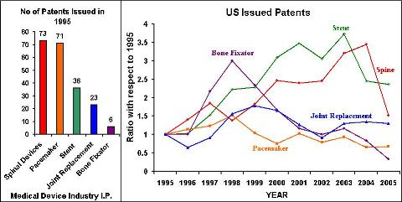

As previously mentioned, the medical industry is still in the growth stage. 3D printing is a fairly new technology, and thus has yet to disrupt the medical device industry. The figure below illustrates this point; while the medical devices industry continues to grow 3D printing is still in the developmental stage. While traditional device users have another 20-30 years before this technology is developed, they should keep an eye on the advances of 3D printing. With promises to be a cheaper, safer, and quicker alternative, 3-D printing is sure to progress from only an emerging technology to a disruptive technology.

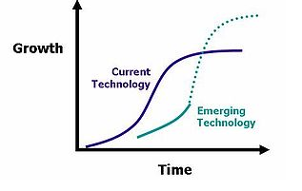
3D
Printing
Medical devices

Key Industry Players

The key players relating to our subject matter will be divided into two groups: 3D Printing players and medical industry players. Each group is acting in distinct ways to create an impact on the industry landscape going forward: 3DP players by advancing the base technology and medical players by leveraging the technology and adapting into their specific uses.

The most key players within the 3DP section are MIT and the 6 3DP licensees, most importantly Z Corp and Integra. MIT is clearly integral because of its initial development of the technology and continued research in 3DP. It also plays a fundamental role in the commercialization of the technology as it holds the base IP for which businesses will either need to license or invent around (if they so choose).

Z Corp is one of the few companies, which has turned MIT’s 3DP technology into an efficient, cost effective, and highly functional package device. The company offers a range of 3DP devices along with scanning and modeling software to give customers and easy to use end-to-end experience.

Integra is a spinal implant devices company, which has licensed the 3DP technology in the production of implants. They offer a variety of implants for spinal conditions from implantable screws to synthetic vertebrae. They will be important going forward both in offering new medical solutions to difficult problems, but also in regards to adapting the 3DP technology to the medical industry.

Within the medical field there are a number of firms who could be identified as key players based on the trajectory of 3DP in health care going forward. Top biotechnology and orthopedics firms will most likely be the most affected and pivotal as 3DP becomes more prevalent in the field of medicine. In the field of Bio-Tech firms like Regeneron, Osiris and Genetech will have keen interests in the potential aspects of 3DP in regards to organ printing. It is most likely that these firms will allow start-ups such as those listed in the regenerative medicine chart to do basic R+D and concept testing and then acquire them for their technology rather than directly investing in the development of 3DP based organ printing. In regards to prosthetics and orthopedic implants, top firms such as Stryker, DePuy, Medtronic, and Synthes will play a more direct role in moving 3DP into the mainstream than their Bio-Tech counterparts do with organ printing. 3DP will allow these firms to produce more specific, customizable solutions to generic operations such as hip and knee replacements. 3DP will also allow smaller firms to begin to compete with large manufacturers in orthopedics (such as those listed) which will force large firms to either innovate faster or adopt technology faster. Potential disruption of these business models will be discussed later on in the paper.

Sources of Technological Knowledge

3D printing will have impacts on a wide variety of industries; however one with the greatest potential is the medical industry. 3D printing may never equal the efficiencies of today’s manufacturing techniques, but shows great promise in areas where only one of something would ever need to be produced and time is a success factor. The medical industry calls for just this solution. In areas such as artificial replacement bones, teeth and prosthetics 3D printing may be a viable solution.

Within the medical industry universities such as the University of Stellenbosch in South Africa are working with 3D printers from Z Corp and exploring possible uses in a wide variety of fields including manufacturing, prototyping, architecture and medical. It is through collaborations like these where we will likely see the game changing developments that will enable 3D printing to revolutionize the medical field. A large dental equipment manufacturer, Planmeca Oy is currently using 3D printers to build models for planning and practice thereby making surgery more successful and shorter. Walter Reed Army Medical Center uses 3D printers to build models for practicing complex surgeries and building models for casting facial prosthetics. Caesar Research Center’s Rapid Prototyping Group has developed a new technique for building “porous ceramic scaffolds” via 3D printer that after sintering become fully implantable and could be used in tissue engineering to rebuild bones. The University of Tokyo Hospital and Next 21 have been using 3D printing technology to make artificial bones for facial reconstruction. 3D models are created from x-ray and CT scans and then printed on alpha-tricalcium phospate. These printed bones have similar characteristics to real bones and are designed to integrate with the patients existing bones and even allow it to be replaced as natural bone regrows. At this point these artificial bones are not strong enough to be used for weight-bearing, however they have an advantage over the technology that Ceasr’s is doing as they do not have to be sintered and resorb more quickly. Bespoke, a company using 3D printers to make prosthetics is a collaborative effort between Scott Summit, an Industrial Designer and Dr. Kenneth Trauner, an orthopedic surgeon/engineer. They are currently making prosthetics for about 1/10th the cost of traditional ones and can do so more quickly and tailored exactly for the individual.

At this point 3D printing within the medical field is used primarily for building models to allow doctors to more accurately study part of the human body in preparation for complex surgical procedures. In the future 3D printing may be able to actually reproduce exact replacements for bones, teeth and even organs. In order to successfully transform 3D printing to that level, doctors, scientists and engineers from multiple industries must work together to improve the technologies and develop new materials and technologies to print them. The collaboration must involve experts from the 3D printing industry, medical professionals, materials scientists and engineers from academia. The new materials will have a variety of properties depending on the application, from color and texture to weight, density and strength. Once these new materials and the associated methods for printing them are developed the opportunities will be endless.

Government regulation, Social Impacts & Ethical Concerns

While there currently are no real regulatory challenges outside of normal FDA compliance for 3D printing, some may come as the technology becomes more popular. The hope is that 3-D bio printing, also known as human organ printing, will one day allow surgeons to order body parts on demand. Patients currently wait on organs from suitable donors for months and sometimes years. During this time period, patients often get worse and even sometimes die. The ability to make organs on demand would reduce the amount of suffering, shorten the healing process, as well as save lives.

Some say bio-printing brings us one step closer to human immortality and refer to the new technology as “God machines”. This issue will impact government regulation because it will be a continuation of the stem cell debate. The advancement of 3-D printing is related to the understanding of stem cells. This raises an ethical and moral issue for many Americans who believe that life begins at conception because embryos are destroyed when stem cells are removed for research.

Artificial organs are a real need. While a strong ethical debate would ensue, stem cell technology is essential to pushing forward the development of 3D organ printing. A man-made biological substitute for a kidney, for instance, need not look like a real one or contain all its features in order to clean waste products from the bloodstream. Those waiting for transplants are unlikely to worry too much about what replacement body parts look like, so long as they work and make them better.

The picture below shows the future use of organ printing.

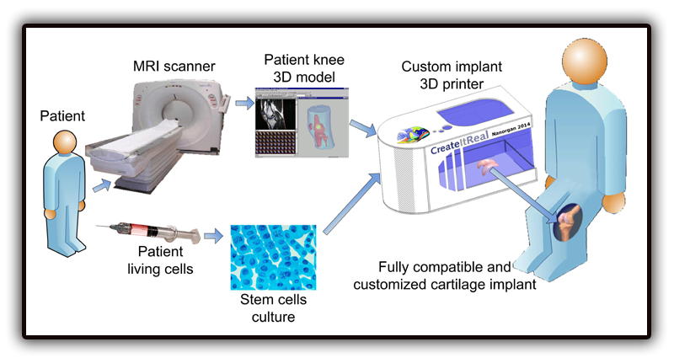

Value Chain Analysis

The value chains for each sub-sector will be defined in terms of their current state and then analyzed based on possible changes due to the advent of 3DP.

Orthopedics is characterized by a large value contribution by the manufacturers, surgeons, and finally hospitals for post implant services. The majority of ‘primary activities’ are completed by implant manufacturers (like many of the firms listed previously) while support activities are the responsibility of hospitals, private practices and surgeons. Clearly the largest value is created with the production of the device (firms) then the eventual implantation/surgery (surgeons/hospitals) and then continued maintenance of the device (hospitals/doctors/private practices). 3DP could be potentially very disruptive to this model. Hospitals and private practices have the potential to backward integrate and replace their suppliers by utilizing cheap 3DP technology. Instead of ordering a base amount of say hip replacement implants, hospitals could instead purchase a set of 3DP machines (amount will vary on size and scope of hospitals needs) which could on a per-patient basis produce customized hip replacement implants. This will however call for the development of new departments within hospitals and practices dedicated to 3DP scanning and production. In a second scenario (keeping with the current value chain) manufacturers could simply adopt 3DP as a custom service provided to hospitals in the case of extraordinary parts needed will still producing generic orthopedic implants. A third scenario could involve a whole new set of implant manufacturers in the form of small regional firms. Firms could work with local hospitals in order to create per-patient implants. This would be very similar to the first scenario except instead of the hospital integrating 3DP into itself small local labs/firms would be contracted for the service, replacing generic parts.

Prosthetics has a very similar structure to orthopedic implants and thus would be subject to similar disruptions and possible scenarios. Because, prosthetics have a tendency to be more personalized and 3DP allows them to be exponentially so, patients will most likely work with their doctor and a contracted third party in the creation of new prosthetics. For example a person who is replacing a missing leg with work with their orthopedic doctor and a decided third party firm to design a specific prosthetic custom to them. It is possibly that a small segment of orthopedic physicians will move into producing prosthetics and make that their specialized practice however on the whole it seems more likely that small to medium sized fabrication labs will service the specialized needs of orthopedic doctors.

In regards to regenerative medicine and organ printing there is no set value chain thus far. Bio-Tech firms, academics and hospitals all have their hand in advancing the technology and their is no clear model for distribution just yet. The establishment of a standard model will heavily depend on the legal precedents and regulations in relation to organ printing. To speculate though it seems likely that two situations arise. Firstly Bio-Tech firms could master the process and be allowed to widely supply hospitals with needed organs for transplants and various surgeries. Secondly hospitals could bring the technology in house and print organs in house on an as needed basis. As stated above the final model will heavily depend on government regulation and the finalized standard practices of the technology/methodology.
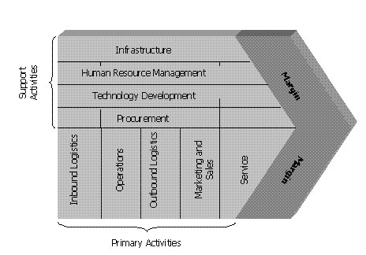

Industry Transformation Analysis

While it is likely that 3D printing will have a large impact on a variety of industries, we feel that it shows the most potential in the medical realm. The first step and opportunity to transforming this area will most likely be within the dental field. There are a variety of industries directly tied to the dental field including Surgical, Medical and Dental Instruments and Supplies, Dental Equipment and Supplies, Medical, Dental and Hospital Equipment and Supplies, Medical and Dental Laboratories, and Dental Laboratories. From the industry prospective, we feel that 3D printing will have the greatest impact on Dental Laboratories. According to the Gale Encyclopedia of American Industries, in the late 2000s, there were about 12,100 dental laboratories in the US employing some 56,750 people. These labs produced custom-made prosthetic appliances for the dental profession and typically were within 50 miles of the dental offices they serviced. They were responsible for almost $3.1 billion in service in the late 2000s.
With 3D printing, this portion of the value-chain may shift at least partially to the dental offices themselves, allowing them to retain more profits. Additional value will shift to the producers, resellers and servicers of the printing devices as well as those firms producing and selling the printing materials.
According to the Bureau of Labor Statistics in 2008 there were 120,200 dentists in the U.S. most of which worked as solo practitioners, making about 90,150 dental practices. This represents a substantial potential market for dental prosthetic capable 3D printers. At a projected price tag of $10,000, and an estimated lifespan of 5 years, this represents potential sales of about $180 million per year.

The second segment of the medical market which 3DP will have a large impact on is prosthetic devices related to orthopedic surgery (limb replacement, bone replacement, joint reconstruction etc). As discussed previously there are a small number of firms in this space who are producing custom prosthetic devices (Bespoke Fairings) and some also producing bone replacements (Next 21). This is clearly an extremely large market which can be considerably impacted by the availability of new efficient and low costs methods of producing implants, prosthetics and supports. It is estimated that roughly 40% of the cost of a hip or knee replacement is the actual cost of the implant itself. 3DP systems can drastically reduce this cost in many ways. Implants and bone replacements which are now specially crafted by labs out of a variety of materials (mostly composite ceramics) can instead produced within the orthopedic professionals own practice with relatively low-cost 3DP machines which are currently available.

Injured soldiers, for example, can get customized limbs in a much shorter term regardless of the complexity even making only one unit. “It costs $5,000 to $6,000 to print one of these legs, and it has features that aren’t even found in legs that cost $60,000 today,” said Mr. Summit, a prosthetic surgeon, a co-founder of Bespoke. And it's not just artificial limbs that may be going through a design renaissance: because of the infinite flexibility of digital designs, almost any kind of physical product could find wide new style, aesthetics, and custom models because of the machines, which can quickly, cheaply, and efficiently produce almost anything that can be imagined and crafted in a 3D modeler. 3DP will also change the way of preparing a prosthetic surgery, the previous procedure for facial prosthetic surgery involved putting plaster on the patient's face to make a mask. Now, with 3DP technology, doctors can use an imaging device, essentially a 3D camera, along with software that creates a map of the person's face with the corresponding prosthetic. The 3D printer can then print out a mask that surgeons can use as a guide for reconstructive surgery.

3DP can also be used in orthopedic private practices with existing technology. CAT scans, bone scans, and available 3D scanning software can be used to give an accurate representation of the model needed and then fabricated on site with a 3DP machine. The largest costs incurred by the practicing surgeon would be the upfront capital expenditure on the machine anywhere from $7-20k depending on the model the machine, materials costs, and servicing. Another alternative scenario would be that existing implant fabrication labs would begin to offer 3DP services as a fabrication alternative to their existing clientele. In the first scenario mentioned a significant movement in the value chain takes place where practicing surgeons are able to provide more value on their own without dealing with a 3rd party fabrication lab. The second scenario remains consistent with the current value chain but disrupts fabrication labs existing technology and services, in which case they would need to adapt and adopt new 3DP methods.

As mentioned previously there are a small number of firms currently operating in this space and it is certainly growing. The main concern is as with many medical practices is the approval process from the FDA. Aside from this hurdle the majority of resources and services are in place in order to facilitate the shift from current fabrication techniques to 3DP fabrication. The major ‘chasm’ if you will for majority adoption is educating practicing surgeons, fabrication labs, and hospitals. Surgeons need to understand the benefits of the technologies, how its used and the impact it will have on their skills as a surgeon, labs need to understand 3DP’s impact on their place in the value chain (which might be upsetting) and hospitals need to understand both the benefits of the technology and the cost savings it offers.

The last sub-section of the medical industry, which will be affected by the advent of 3DP technology, is regenerative medicine. This is a new filed which encompasses things like stem cell research, tissue engineering, and organ generation. 3DP offers a unique advantage to this field, the possibility of one-of-a-kind artificially generated organ replacements. 3DP allows for living cells to be ‘printed’ onto successive layers of gel composites in a specific shape upon which they grow and eventually form a specific organ. This may also be used not only to grow synthetic organs but also specialized cartilage based body parts such as ears and noses. Even though this application of 3DP technology is currently being used and researched by firms and universities it is certainly much further from widespread acceptance than dental and prosthetic applications.

There are a variety of hurdles for majority adoption, which are much more wide spread than those of prosthetics. The first would be a solidified and proven technology. Organ printing is still in development and there are a variety of practices involved all of which would need to be refined in order to provide any type of widespread adoption. The major issue associated with organ printing now and even after the technology is solidified are the ethical concerns it raises. Stem cell research is extremely polarizing and synthetic organs are certainly as controversial. People are concerned not only with how stem cells are harvested, but also the bio-cyborg issues that something like printed organs represent. Is it our place to generate organs? How is putting a synthetic organ in me different than a computer chip? Who gets priority over the supply of synthetic organs? The needy? Those who can pay? How long can we use synthetic organs to prolong our lives? Do I lose my humanity through the implant of synthetic organs? The list goes on and on. These concerns do not only affect those who would wish to have or potentially use the technology but the regulatory environment around it. Society’s sentiments on these issues will determine the laws and governance around the technology, its availability and eventual implementation. Organ printing has an uncertain future and although it promises an application, which could dramatically revolutionize the medical field, its ethical implications threaten to change the fabric of our society as a whole.

Summary
The umbrella term 3D printing has been applied to a number of additive manufacturing processes developed throughout the mid 1980’s and 1990’s. MIT’s 3DP or inkjet 3D printing technique commercialized by a small number of licensees has gained foothold through a variety of devices most notably Z Corp’s line of all in one 3D printers. 3DP offers users the most flexibility in printing from a diverse range of materials (it can print with any material available as a powder) to full color rendering. This technology has distinct ramifications for the medical industry and more specifically: orthopedics, prosthetics and regenerative medicine. Currently orthopedic implants compose roughly 40% of the cost of an orthopedic operation; 3DP can not only reduce this cost, but also improve the quality of the implant. Implants can be printed on a per-patient basis and customized easily to the patient’s needs. Similarly prosthetics’ costs can be reduced while customized not only to patient’s needs but also potentially patient’s style. Moving forward there are two likely scenarios for value chain models in regards to 3DP. Firstly it is possible that hospitals and private practicing doctors would backward integrate and incorporate 3DP into their services offered. For example when you went to an orthopedic surgeon for a hip replacement instead of using a stock order ball and cup replacement, a department within your doctor’s office would print a custom implant specific to your needs. A second scenario is that small to medium sized firms would begin to specialize in this service acting as contracted services for doctors and hospitals. It is also certainly possible that these two scenarios could be combined created a hybrid system with some doctors outsourcing 3DP services to contractors while some keep it in house a specialty. As of yet it is believed that the value chain for regenerative medicine, more specifically organ printing, will be highly dependent on the eventual regulatory environment surrounding this practice.
Going forward, 3D printing’s immediate promise is in areas such as orthopedic implants, dental replacements, and prosthetics. The technology is readily available and knowledge is being disseminated. Eventual adoption will depend on educated practicing doctors and hospitals of the available benefits and tremendous cost savings. Regenerative medicine and organ printing however have a much more uncertain future. The practice is the center for much debate and poses ethical implications not faced before. As the technology develops its adoption and eventual commercialization will depend heavily on government regulation and the overall socio-political climate.

Appendix

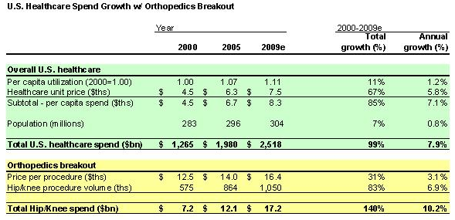

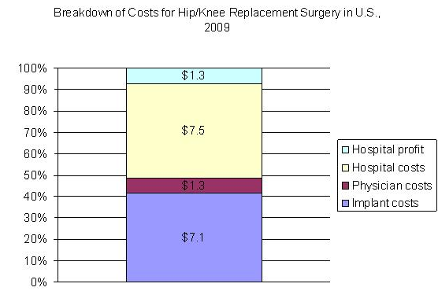

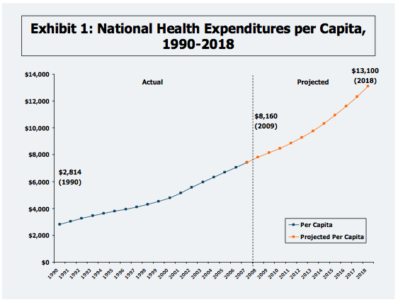

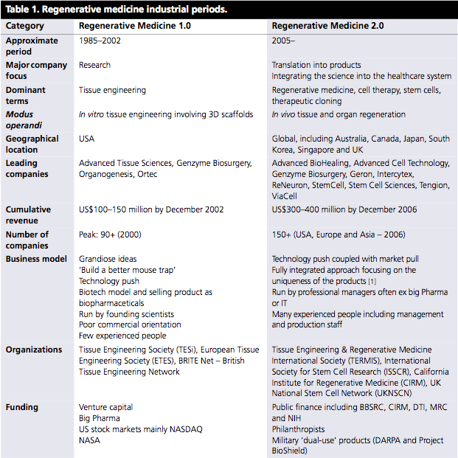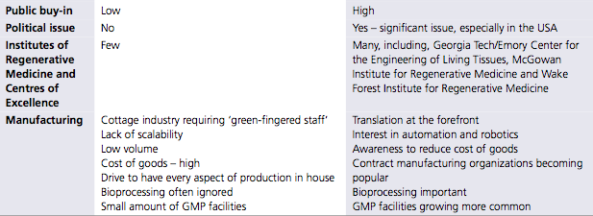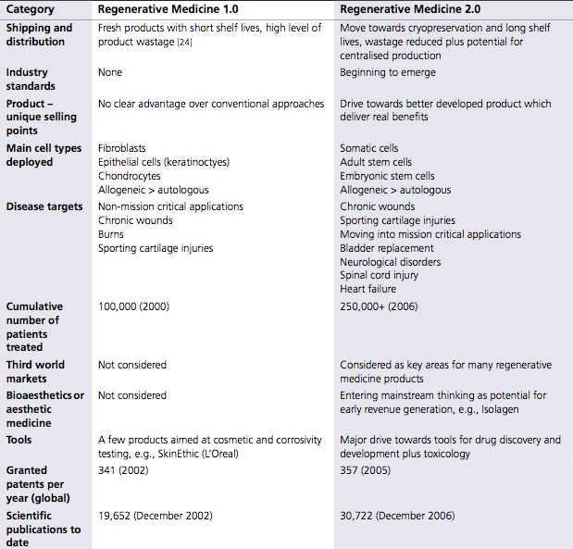
WORKS CITED:

“Printing body parts – Making a bit of me.” The Economist. 18 Feb. 2010. <http://www.economist.com/research/articlesBySubject/displayStory.cfm?story_id=15543683&amp;subjectID=526354&amp;fsrc=nwl>

Weinberg, Michael. “It will be awesome if they don’t screw it up.” PublicKnowledge.org. Nov. 2010 <http://www.publicknowledge.org/files/docs/3DPrintingPaperPublicKnowledge.pdf>

“Organovo develops first commercial 3D bio-printer for manufacturing human tissue and organs.” Organovo. 1 Dec. 2009. <http://www.organovo.com/news1.php>

Kluger, Jeffrey. “3-D Bioprinter.” Time. 11 Nov. 2010. <http://www.time.com/time/specials/packages/article/0,28804,2029497_2030617_2029812,00.html>

Negis, Erkut. “A short history and applications of 3D printing technologies in turkey.” TurkCADCAM.net. 24 Sept. 2009. <http://www.turkcadcam.net/haber/2009/rapidtech-workshop/presentations/Presentation05.pdf>

King, Rachel. “Printing in 3D gets practical.” Bloomberg Businessweek.” 6 Oct. 2008. <http://www.businessweek.com/technology/content/oct2008/tc2008103_077223.htm>

Terdiman, Daniel. “3D printing to make prosthetics molding easier.” Crave. 9 Mar. 2010. <http://asia.cnet.com/crave/2010/03/09/3d-printing-to-change-prosthetics/>

“Need a prosthetic leg-3D printing will be able to generate one for you soon for around $5000.” The medical quack. 13 Sept. 2010. <http://ducknetweb.blogspot.com/2010/09/need-prosthetic-leg3d-printing-will-be.html>

“Emerging trends in the medical equipment industry.” PartneringNews. 19 May 2010. <http://ebdgroup.com/partneringnews/2010/05/emerging-trends-in-the-medical-equipment-industry/>

“Occupational Outlook Handbook, 2010-11 Edition.” Bureau of Labor Statistics. <http://www.bls.gov/oco/ocos072.htm>

“8072 – Dental Laboratories.” Gale Group - Business & Company Resource Center. <http://galenet.galegroup.com.libproxy.rpi.edu/servlet/BCRC?vrsn=unknown&locID=nysl_ca_rpi&srchtp=ind&ids=dental&c=1&iType=sic&mode=i&ste=85&tbst=tsIS&cind=8072+-+Dental+Laboratories&tab=1024&docNum=I2501400934&bConts=5923>

“Artificial bones made with 3D inkjet printers.” PinkTentacle.com. 13 Aug. 2007. <http://pinktentacle.com/2007/08/artificial-bones-made-with-3d-inkjet-printers/>
“About.” Bespoke prosthetics. <http://www.bespokeinnovations.com/prosthetics/home/home.html>

“’ZPrinted’ 3D models help improve oral surgery.” ZCorporation.com. 1 Sept. 2010. <http://www.zcorp.com/en/Press-Room/ZPrinted-3D-Models-Help-Improve-Oral-Surgery/news.aspx>

“Multicolor 3D-printed surgical models improve patient outcomes at walter reed.” ZCorporation.com. 23 Feb. 2009. <http://www.zcorp.com/en/Press-Room/Multicolor-3D-Printed-Surgical-Models-Improve-Patient-Outcomes-a/news.aspx>

Seitz, Hermann; Rieder, Wolfgang; Irsen, Stephan; Leukers, Barbara; Tille, Carsten. “Three-dimensional printing or porous ceramic scaffolds for bone tissue engineering.” Journal of Biomedical Materials Research. 24 Jun. 2005. <http://onlinelibrary.wiley.com/doi/10.1002/jbm.b.30291/abstract>

