Professors Chris McDermott & Jeff Durgee
The Lally School of Management &Technology : RPI
Fall
10
DMM | Milestone 1 | Herman Miller
08
Fall
Jon Ashdown | Greg Frisch | Danying Li
Michael Manning | Kudzanayi Mugomba | Nadeem Omar

Office Furniture Industry:

As of 2009 the office furniture industry did $7.85 billion in revenue and is projected to do $8.2 billion in 2010. The industry as a whole is directly correlated to the macro economic environment and GDP output. The market is host to a few large players (manufacturers mostly) and fragmented section of distributors. Large manufacturers include the HNI Corporation (A public firm which is comprised of a number of subsidiaries including AllSteel) Herman Miller (A private manufacturer) Knoll (A public firm founded by designer Florence Knoll) and SteelCase (A large public manufacturer with several subsidiary brands).
Although customers (business looking to furnish their offices) can order directly from manufacturers distribution is mostly facilitated by regional furniture distributors and designers working for customers. For example Global Foundries is opening a large-scale office in Malta, NY, they are working with a regional furniture supply company Accent Commercial Furniture as well as interior designers to choose their furniture and purchase it. Accent works as an intermediary between manufacturers (mostly Herman Miller) and customers.

I WILL ADD MORE HERE : Mike

Segmentation and Target Market Choice

Customer Markets are segmented into purchasers that use high and low end furniture as well as used furniture. Customers in these markets are segmented by their office furnishing budget constraints. Executives or law offices will opt for higher end office furniture because of their more discerning tastes and larger budgets. Startup companies with limited budgets and desire for no frills functionality by low end or used furniture. We have determined to target the high end furniture market. The high end market comes with a demand for high functionality and more forward-looking designs and capabilities.
There is also a customer segmentation of small and large companies which make use of the furniture. Large companies will have specialized facility managers which act as buyers (described in more detail in the next paragraph) and will require more customized attention through the buying cycle. Small companies on the other hand do not have specialized decision makers and their main concern is the business operations. They purchase office furniture for functionality and are concerned with the constraints of their facility. We have decided to target large companies who will focus on larger purchases and higher functionality.
An important distinction in the customer market is that the Buyers and End Users of the office furniture are not one in the same. Buyers of office furniture are facility managers and specialize in capital improvements for their company’s offices. Facility managers are also in charge of general upkeep including cleaning and managing repairs. End Users are office workers who will be using the product. End Users have

Qualitative

Exploratory Study

After we were randomly assigned to becoming Team 11, we began to focus on the next steps and stages of defining our market. Office furniture and lighting as it stands is a very broad industry. In-line with understanding customer needs and the general outlook of office furniture we decided to conduct an exploratory study. To our disposable and reference Mr. Michael Lobsinger a previous RPI DMM student had approached Professor’s Durgee and McDermott with a proposal of working with any DMM groups interested in lighting. To that accord the Lighting and Research Center (LRC) gave us a tour of their facility and gave us a synopsis of some of the new technologies related to lighting and office furniture. The whole group toured the research center armed with notebooks and a litany of very inquisitive and specific questions with the intention of narrowing our research industry. At the end of our tour and meeting with Mr. Lobsinger the group met to debrief and compare notes on some of the highlights and potentially viable ideas generated from our meeting and tour. Since our parent company for our industry of choice is Herman Miller, and the LRC is primarily a lighting research center; our focus shifted into smart offices, and how light affects office furniture and work productivity.

The LRC also hosts monthly seminars at RPI aimed at informing students on some of the new innovative changes occurring in the lighting industry. The group managed to attend, “Thinking Differently about LED Lighting” and “New Models in LED Lighting” with the intention of narrowing our research field, understanding customer needs, understanding the market trends, and networking with industry professionals. Apart from using the LRC as a resource center, we engaged in phone interviews and one-on-one interviews with different friends and professionals working in offices and open spaces to get a general idea of some of their concerns and frustrations. We interviewed and recorded various professionals as a way of matching up and comparing notes with fellow interviewees; In one of our interviews with a Mr. Pleasant Despain an accomplished author currently working on multiple projects when asked how he organized his desk he said that, “My work area is my holy sacrament, and I cannot work in a disrupted environment, a dirty environment, a messy desk.” He went on to mention that, “…as a writer I often have multiple manuscripts open, dictionaries, research materials, small scribbled innovative action plans, other novels, my computer, you name it, and yet the dichotomy of my situation is that I can’t work in a messy environment.” Our other interviews kept on highlighting the idea of multiple projects yet yearning for a cleaner work environment. At this point we began forming a gap analysis highlighting the different attributes that kept on recurring in our interviews. We created perceptual gap maps based on overall similarities that we had come across.

After further narrowing our industry based on perceived customer needs we created an online ‘monkey survey’ further narrowing our industry focus. We came across a few interesting comments by our respondents when we asked them how they viewed their work area they responded by saying, “My co-worker who I share an office with is very clattery”, “When I am working on a huge project I often have to use the conference room to spread out my work, but I waste time going back and forth to my office to recover files”, “I have many cabinets to store my papers”. When we asked them follow up questions as to ways they thought they could improve this aspect of their work areas our respondents echoed these comments, “I need more labeled stackable file trays. I have them but I am too lazy to label them and organize all of my papers”, “I have some papers in files but I mostly have stacks all over my desk. I think it could be improved if I spent time organizing my papers”, “…Archived papers go in a drawer in hanging file folders….Active papers are in semi-organized piles on my desk, and I would prefer a better solution for this.”

In line with broadening our market research and understanding perceived customer needs we decided to establish contact with a few local businesses that sell and resell office furniture. We targeted 3 major companies in the area Accent furniture, Tech Valley Office Furniture, and Design Logic Architects. At Accent Furniture we also managed to speak with the Herman Miller representative our parent industry to which we would like to use as a distribution center for our finished product. Since there are six people in our group we teamed up in pairs and managed to secure interviews with the CEOs of these respective companies. With two people asking questions and simultaneously taking notes we got some very interesting ideas that we managed to catalogue in our ‘dropbox folder’. When we asked the CEO of Tech Valley Office Furniture, Mr. Rod Dion about changes in office furniture and the next wave of inventions, he jokingly replied saying that there is an old verbiage in the office furniture world that all the inventions have been created and done already, everything else is ‘incremental innovation’. Surprised by this remark we asked Mr. Dion to explain and expand on this thought, after a long winded history of office furniture he mentioned something about ‘never having a synchronized way of organizing current projects’. This was our ‘eureka moment’, we then spent the better part of our interview in a 'rogerian' fashion allowing Mr. Dion to fully express his opinions on this matter. (The CEO of Accent Furniture, Mr. waiting for some input)

Methods Used
Upon implementing the research and perceiving market idea concepts we learnt in class on top of our priority list of questions and concepts we wanted to address are; products that customers can not do without (CADWO), how we and in what ways we could improve a certain product, and according to Mike Ensley addressing customer’s “Buuurrrrning needs”. Using these guidelines and imploring the use of Rogerian questioning, video, audio, and customer observation we managed to coin our interviewing strategies. Because of our market segment we had a hard time establishing a ‘focus groups’. We often came across no more than two people willing to be interviewed at a specific time. To clearly portray what we learnt and discovered in our interviews we took pictures, recorded audio interviews when allowed, and took notes along the way. We also made sure to de-brief after every interview comparing notes and citing the high and low points.

Target Segment
By choosing office furniture we immediately segmented our market. The demographics of our potential customer base was now based upon whether a person worked in an office environment or not. From our exploratory interviews the main items we used to obtain a market segment understood the perceived risk, the needed reflected from potential customers, the general advantages over existing products, the ease to use and complexity our product would pose.

Concept results

In the ideas concept test, respondents are asked 4 questions: “How much do you like this product?”; “how unique is this product?”; “how likely would you be to buy this product?”; and “how likely would you be to give it up if you used this product on a regular basis for 6 months?”.

Among the 10 product ideas, the mess manager is the clear winner, closely following by SMART file cabinet. In our 16 valid questionnaires, the occupations of our respondents are diversified: dentist, writer, engineer, lawyer, architect, social worker, banker, etc. In regarding to some products such as SMART partition and rubber chair wheel, respondents rate very differently. But all respondents demonstrated a strong interest in products that helping organizing office space. Thus, it is not hard to draw a conclusion that the need for organization in an office context is at the top.

As the results of 10 product ideas are somewhat close, in order to select the winner of 10 product ideas effectively, we set the weight of 4 questions in different values. First, we evenly distributed the weight, each 25%. Then we increased the weight of one of the factors to 40% and weights of other factors remained even distributed. All the results reveal that mess manager is the winner no matter priority of 4 factors changes.

Early Operations Considerations

The mess manager can easily produced using a flow shop model, the product is feasible and all skills/parts will be readily available. Final assembly will be completed in-house and the creation of most other parts will likely be outsourced. Material selection will depend on further attribute testing including: whether the product will be built into a desk or be modular and take up desk space. Based on current research, molded plastic, wood, or metal could all be incorporated into the final design. Each of these materials demands a different skill set and equipment. A multitude of equipment could be required in assembly of the product including: injection molding, table saw, band saw, sanding machine, metal bender, paint booth etc; therefore operators will past experience using these machines as well as working in a flow shop will be sought to staff the operation. The largest operational challenges will be the tradeoffs between functionality & aesthetics and what parts to outsource versus manufacture in-house from raw materials. Additionally, extreme effort will be taken to create a product that uses minimal fastening devices such as screws and rivots.

Appendix

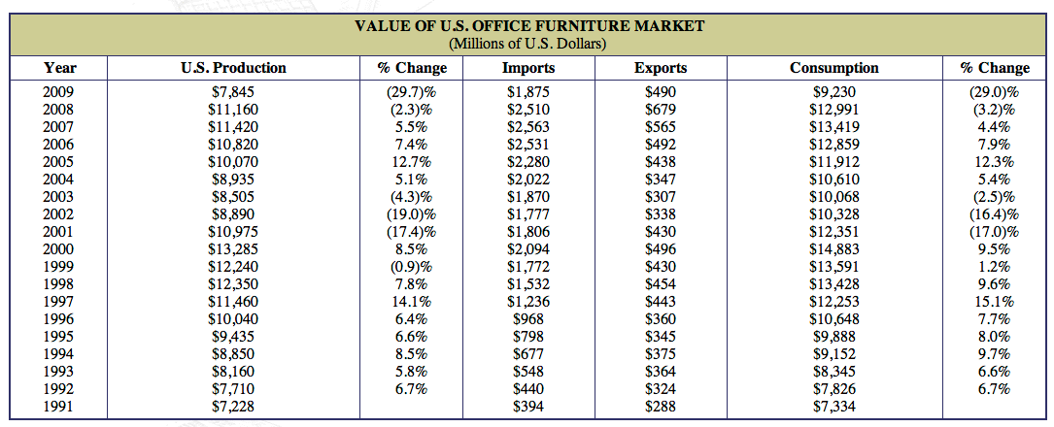

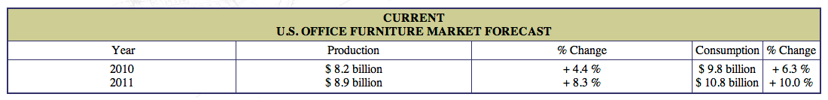

 |  | 25% weight | Like 40% | Unique 40% | Buy 40% | Give up 40%
1 | Conference table with rail sys. | 57 | 61.6 | 58.2 | 57.8 | 50.4
2 | SMART partition | 60.25 | 64.2 | 63.4 | 60.6 | 52.8
3 | SMART file cabinet | 64.25 | 66.4 | 68.6 | 64.4 | 57.6
4 | LED wall mount light | 59.25 | 60.2 | 63.8 | 60 | 53
5 | Mess manager | 65.75 | 68.4 | 69.6 | 65.8 | 59.2
6 | Task light | 56.25 | 60.2 | 57 | 58.4 | 49.4
7 | Rubber chair wheels | 49.75 | 52.6 | 52.6 | 50.8 | 43
8 | Idea couch | 49.25 | 53 | 51.8 | 49.4 | 42.8
9 | Speaker | 60.5 | 63.6 | 64.4 | 60.6 | 53.4
10 | Dry erase desk | 56.75 | 61 | 60.8 | 57.2 | 48

